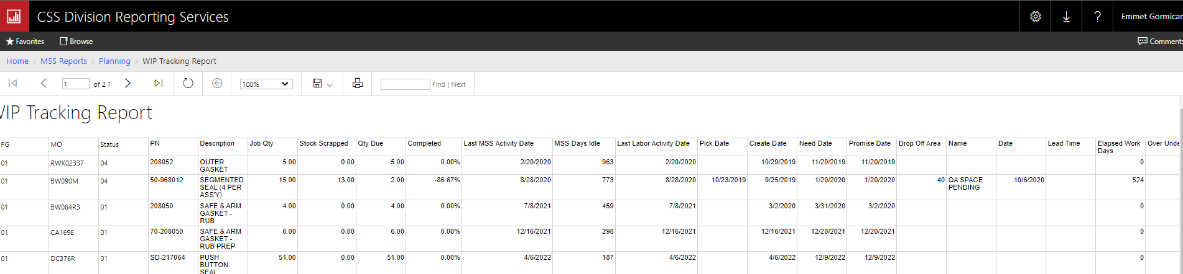

+

Scanning lead time = expected days within current location (lead time plus the date), this is already calculated as ‘over under LT’ above

+

MSS Lead time (days until stock) = scan to last activity completed, then add all the lead times of all uncompleted tasks, presented as number of days

= lead time minus days stilling without work on lead time number of days, so add the days it’s been sitting there

+

Projected stock date = todays date plus the dust number = presented as a date

+

Over under = promise date delta projected stock date, presented as an integer, neg ahead schedule, pos behind based on promise date

